SSCO Module-Based Learning

**Administrator User Manual**

# Preface

This user manual is written for SSCO Module-Based Learning users who are designated as administrators. This manual will guide them on how to effectively use and administrate the SSCO Module-Based Learning application.

# Table of Contents

Preface 2

Table of Contents 3

Introduction 5

Getting Started 6

SSCO MBL - Administrator Interface 7

General Page Layout 7

Main Content 7

Sidebar 8

Administrator Home 9

Users 10

View All Users 10

View a User 10

Create User 11

Edit User 12

Delete User 13

Modules 14

List View 14

Grid View 15

Create Module 16

Modify Module 21

Viewing a Module 22

Deleting a Module 22

Search Module 23

Module Questions 24

Creating a Question 25

Editing a Question 26

Viewing a Question 27

Scheduled Tests 28

Creating or Editing Scheduled Test Questions 28

Including Questions to the Scheduled Test 28

Conducting the Scheduled Test 29

Stopping the Scheduled Test 29

Test Results 30

Module Test Results 31

Scheduled Test Results 32

Test Result Form 33

Trainees 35

Module Test Results 36

Scheduled Test Results 37

Module Enrolment 38

Index 40

# Introduction

SSCO Module-Based Learning is an e-learning web application primarily designed for the new hires of the SSCO department. Its goal is to enable the new employees to more effectively learn and understand the SSCO Department’s massive collection of documents by presenting information in easy-to-understand modules. As administrators to this application, the trainees rely on you to maintain the quality of the modules as well as other functions.

The list below includes some of SSCO Module-Based Learning’s features for administrators:

* SSCO Module-Based Learning administrators can create, modify, and manage module content. This allows them to make sure the module content remains as accurate and as easy-to-understand as possible. In addition to managing module content, administrators can also create, modify, and manage module test questions.
* The administrators can also setup and conduct scheduled tests to evaluate the current skills of all employees under them. These scheduled tests will also let them know how much the trainees have learned and what modules may need refining.
* Administrators can also create, edit, and delete users. Managing users allows the administrators to keep the records up-to-date by creating accounts for new members and deleting those you are no longer part of the team.
* Administrators will also be able to manage the trainees. They can enrol/unenrol trainees from modules as well as view all the trainees’ module and scheduled test results for more in-depth information about the trainees.

This manual will provide detailed information on how to use the SSCO Module-Based Learning tool and how to make the most out of this application.

# Getting Started

Before using the SSCO Module-Based Learning application, please make sure that your web browser is a recent version of Google Chrome. Other browsers may have some problems in displaying the application correctly. JavaScript must be enabled because some of the application’s functions depend on it.

Navigate to the SSCO Module-Based Learning homepage (depends on how the server was setup, but usually http://some_ip_address/ssco_mbl).

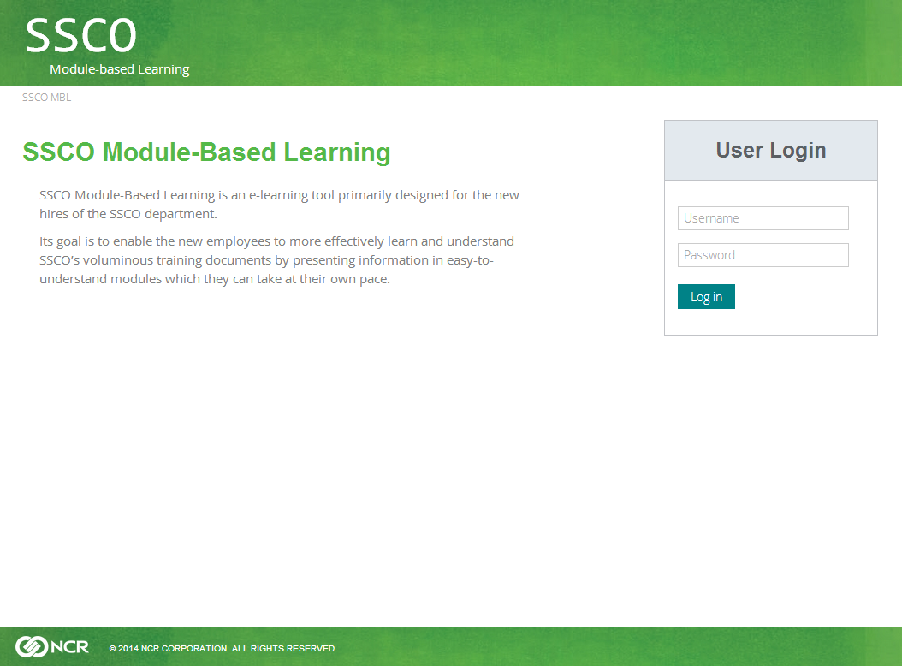

In the “User Login” form, enter your account details. On first use, use “admin” for the username and password. Click Login to enter the site. Please change the admin password to prevent unauthorized access. Refer to Edit User (on page 12) to learn how to edit the password.

# SSCO MBL - Administrator Interface

## General Page Layout

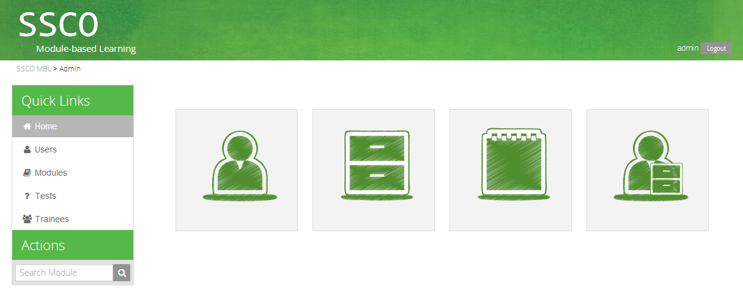

Sidebar

Main Content

The picture above shows the home page, where you will go to right logging in. The home page, as well as other pages has the same main areas, which we will describe below.

1. Main content area
2. Sidebar - Quick links and Actions

### Main Content

The main content area is where your requested information will be shown. The content depends on what page you are in. For example, the administrator home page shows the main functions available to administrators.

### Sidebar

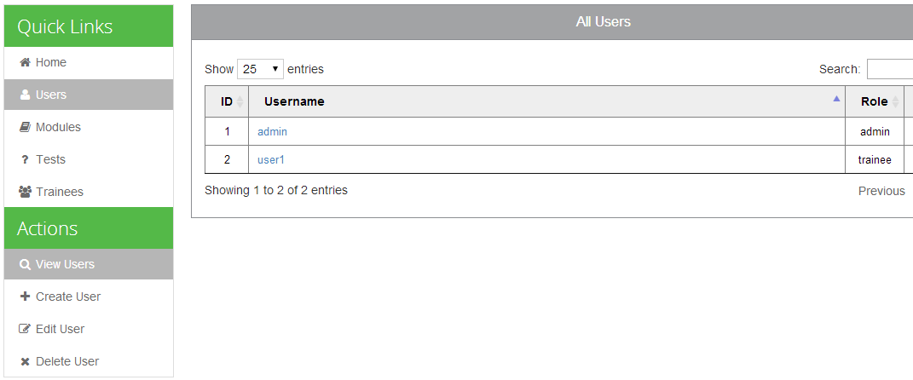

The sidebar provides useful links and actions. Quick Links provide links to the most commonly used functions of SSCO Module-based Learning. For administrators, you have Administrator Home (on page 9), Users (on page 10), Modules (on page 14), Test Results (on page 40), and Trainees (on page 45). These pages will be discussed later.

Actions provide functions related to the page you are currently in. For example, when in the Users page, you will be able to create a user by clicking on the link in the Actions pane. You can also edit or delete users using the respective links.

## Administrator Home

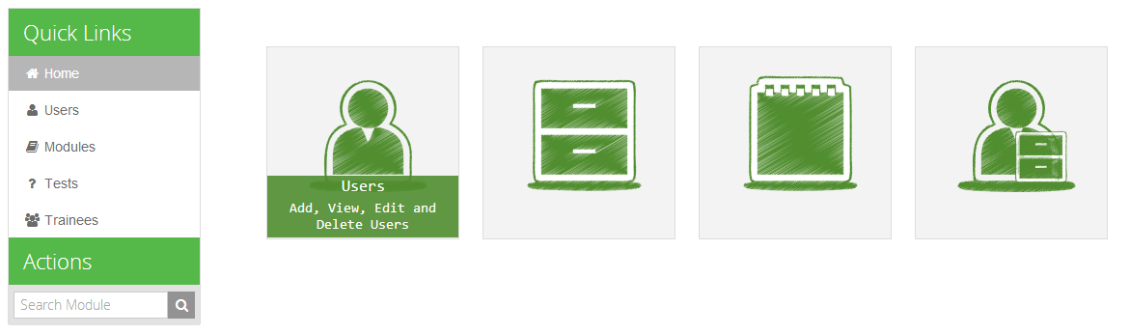

The administrator home page shows the four main functions available to you: Users, Modules, Test Results, and Trainees. Hover on the thumbnail to show more information. Alternatively, you can click on the links in the sidebar.

## Users

### View All Users

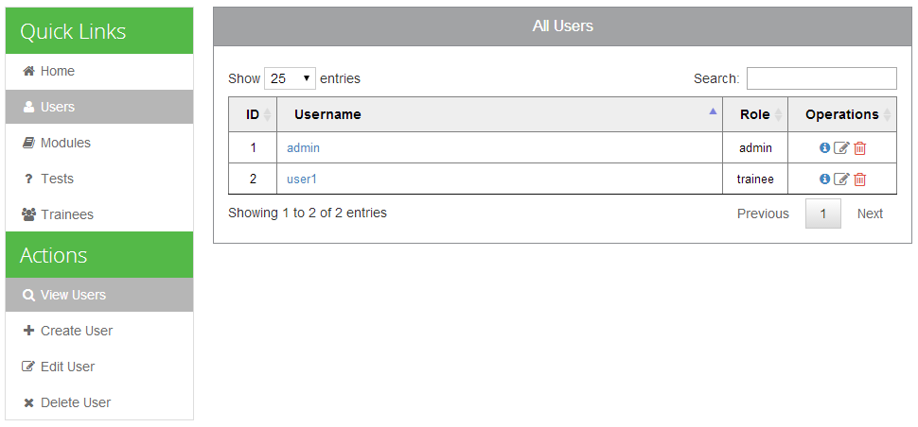

The Users page shows by default a list of all the users, their roles, and actions (view, edit, and delete). You can filter users by username or role using the search bar.

### View a User

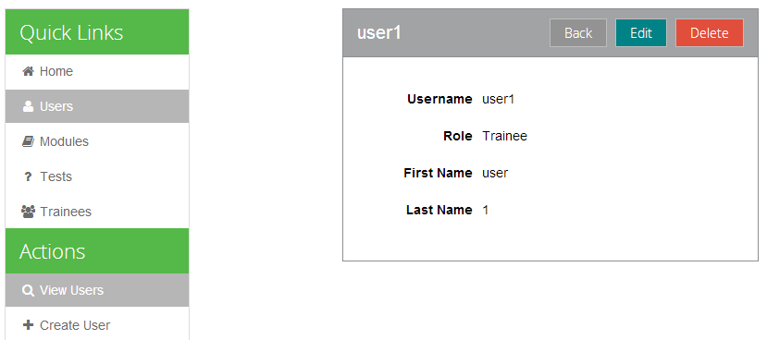

When you click on the name of the user or the information icon, you can view the user’s details. For users with trainee roles, you can view their first name and last name. You will also be able to either edit or delete the user by clicking on the buttons.

### Create User

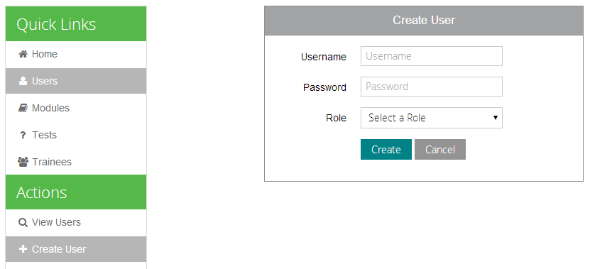

This page is where you create users. You have to fill in the username, password, and role fields. If you designate the user as a trainee, you will have to fill in the first name and last name fields as well. You will not be able to create a user unless all fields are filled in. The username must be unique as well.

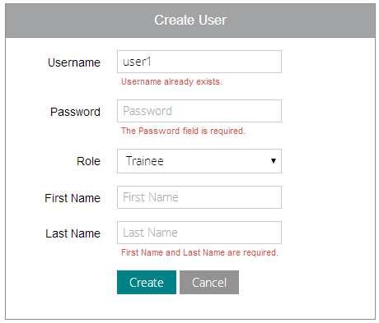

### Edit User

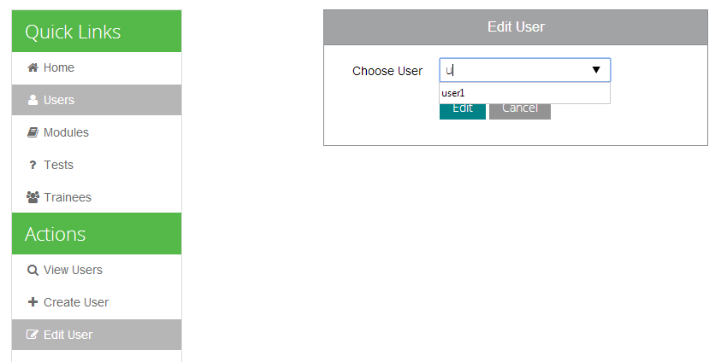

The Edit User page allows you to choose which user to edit. You can also edit a user through the View User page. Type the username or choose from the dropdown list. After clicking the Edit button, you will be shown the Edit User form.

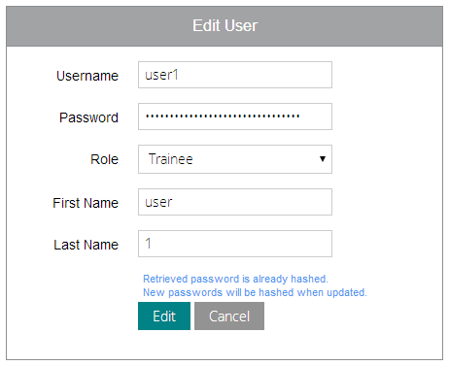

The form is similar to the Create User form above. Note that the retrieved password is hashed. You can leave the password unchanged; it won’t be hashed again if it is unchanged.

### Delete User

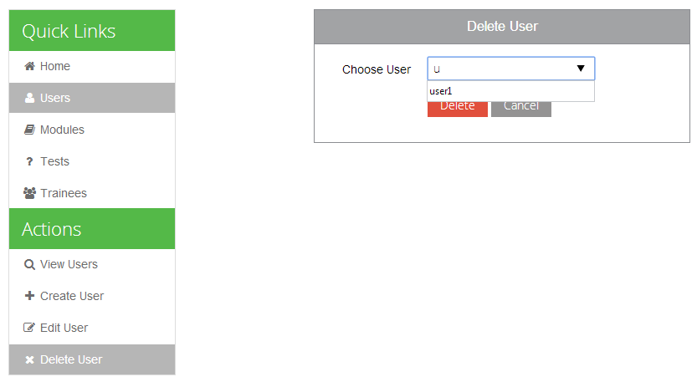

Through the Delete User page, you can choose which user to delete. Type the username or select from the dropdown list. You can also delete a user through the View User page.

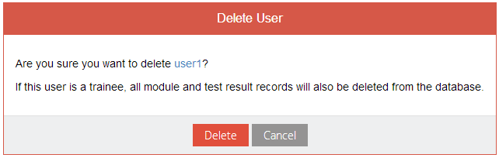

Deleting users will delete all of their records in the database. For trainees, all of their module records and scheduled test results will also be deleted. Click the Delete button to permanently delete the user.

## Modules

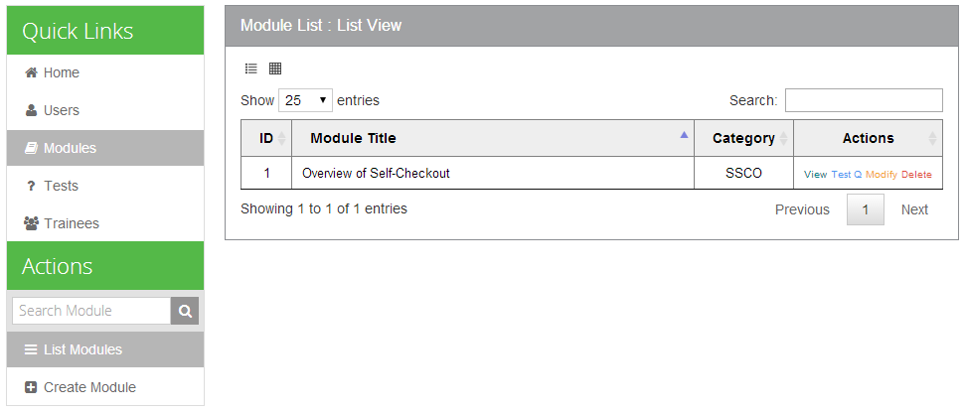

The Modules page contains all functions related to the SSCO modules. This page allows you to create, modify, view, or delete modules. This page lists all the modules that are created and has two modes of view: List View and Grid View.

### List View

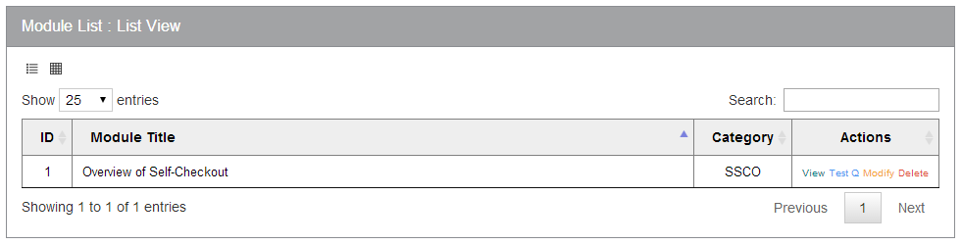

In the default list view, module entries are listed in a table with their corresponding actions in the rightmost column. You can view, modify, or delete the module. You can also view the Module Questions. You will also be able to search for modules or their content by using the search bar at the upper-right corner of the panel.

### Grid View

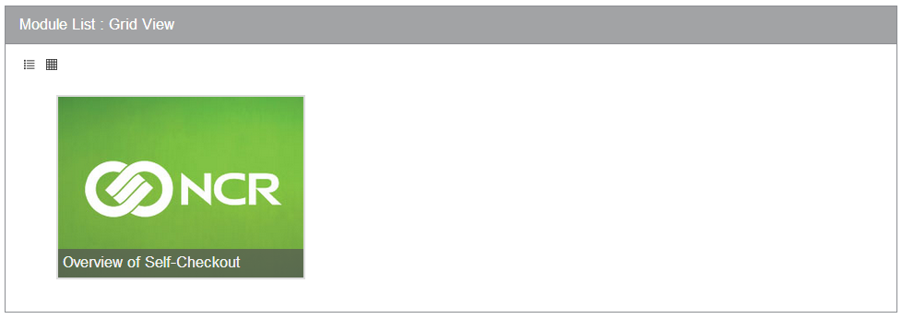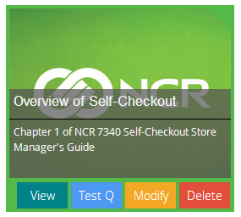

The grid view presents the modules as clickable thumbnails. When you click on a module, you will be see its description and be able to view, modify, or delete the module, as well as viewing the Module Questions by using the buttons below the description.

### Create Module

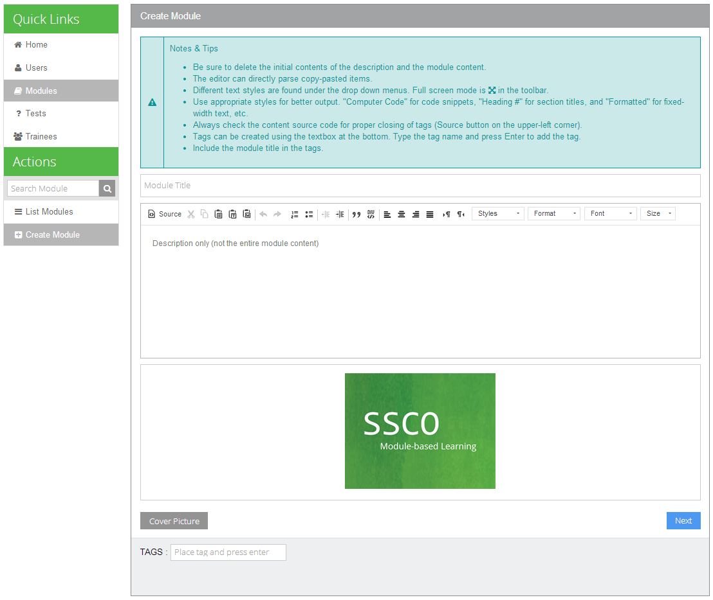

The Create Module page allows you to create modules. Please read the Notes & Tips to be guided on how to properly create modules.

#### Title



Choose a title that is concise and to the point. It should not be too long; you can put the excess words in the description.

#### Description

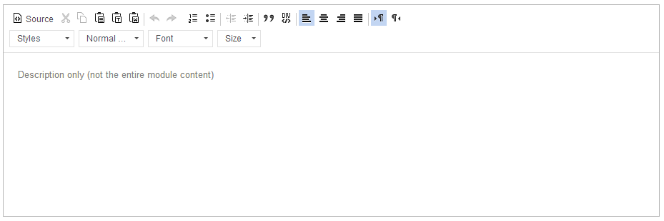

The description should give a brief overview of the module’s content. It can serve as an introduction to the topic the module will talk about. The text editor has some style options. You can use those to improve the presentation.

#### Cover Picture

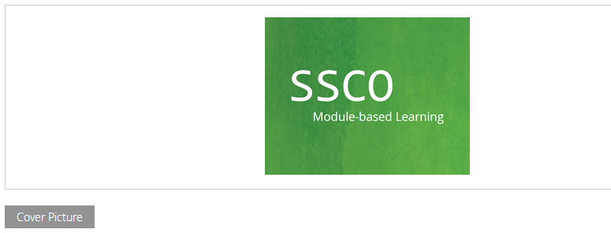

The cover picture will be shown in the Module Grid View. Click on the Cover Picture button to choose an image you want to use.

#### Tags

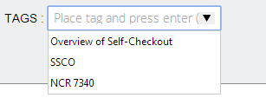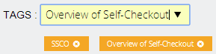

Tags are used for Search Module. You can choose from the list of tags or create new tags. Press Enter to add the tag to the module. You can also remove the tags by clicking on the (X) button on each tag. You can only add up to five tags per module.

After putting the tags, click the Next button to proceed to the next steps.

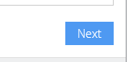

#### Main Content

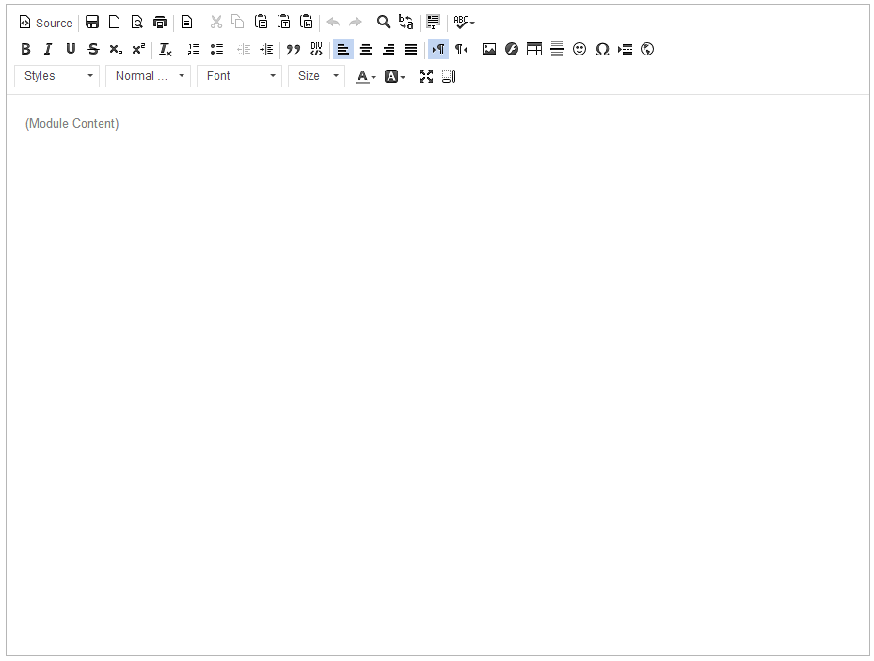

This is the main content’s rich-text editor. You will put the module content here. This editor is quite similar to other word processors; as such, it should be quite familiar. As mentioned in the Notes & Tips, please take note of the following points:

* You can copy-paste from other editors: for example, when you copy from Microsoft Word, the formatting will be kept.
* Use appropriate styles for better output. Of important note are the headings. Always mark section titles as headings: these headings will be used to automatically generate the Table of Contents when viewing the module. Improperly used headings will break the table of contents.

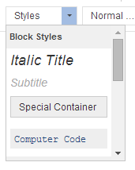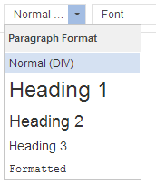

* The text editor output is in HTML. You can directly edit the HTML and even add styles, but please ensure that the tags are properly closed.

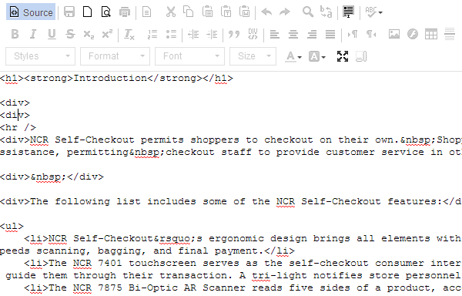

* There are many more features of this editor. You should explore it many functions.

When you are done creating the module, click the Save button to save the module to the database.

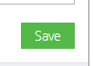

### Modify Module

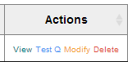

You can modify a module by clicking on the appropriate link in either the List View or Grid View. Modifying the module is similar to creating a module. Just refer to the instructions above.

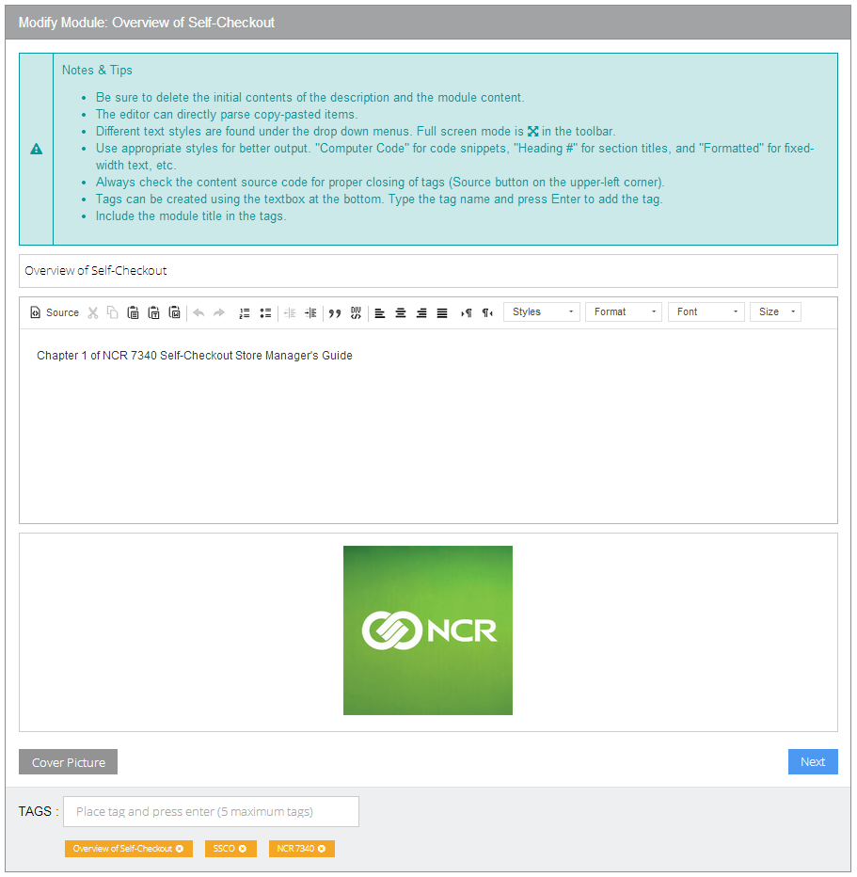

### Viewing a Module

You can view a module by clicking on the View button in the List View or Grid View.

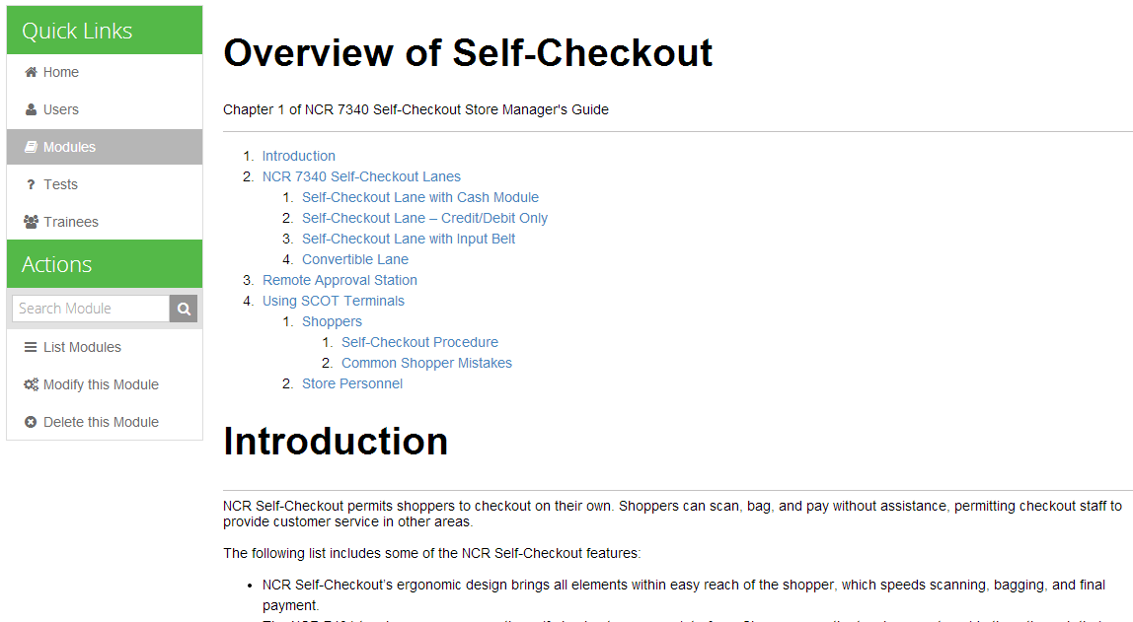

Table of Contents

Title

Description

Content

Available Actions

In the View Module page, you can be able to perform actions pertaining to the module by clicking on the links in the Actions pane. You can modify or delete the module.

### Deleting a Module

You can delete a module by clicking on the link in the List View or Grid View, or though the Actions pane when Viewing a Module.

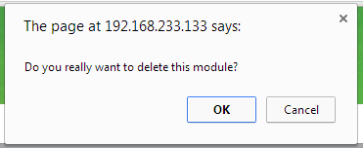

When you delete a module, you will need to confirm the deletion.

### Search Module

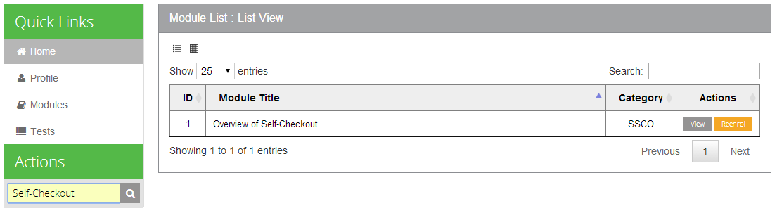

You can search for modules using the search bar in the Actions pane. You can search by title (or parts of it) or by tags.

## Module Questions

Module test questions are used when trainees take the module tests to complete their enrolled modules. Each module test consists of up to ten random questions retrieved from the database. As such, it is recommended to have more than ten questions per module.

When you click on the module’s “Test Q” button in the List View or Grid View, you will be able to see the module’s test questions. Here, you can create or edit questions.

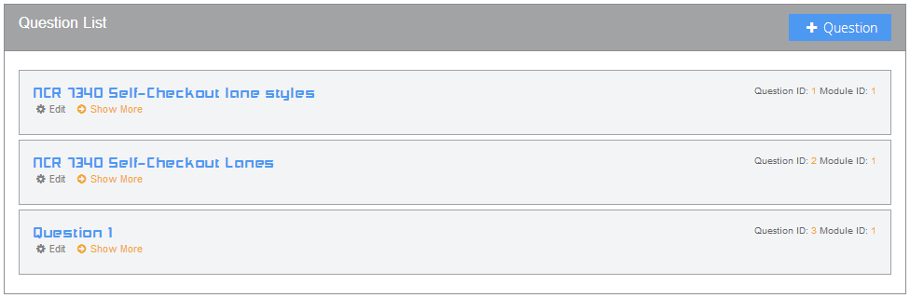

### Creating a Question

Click on the “+Question” button to create a new question.

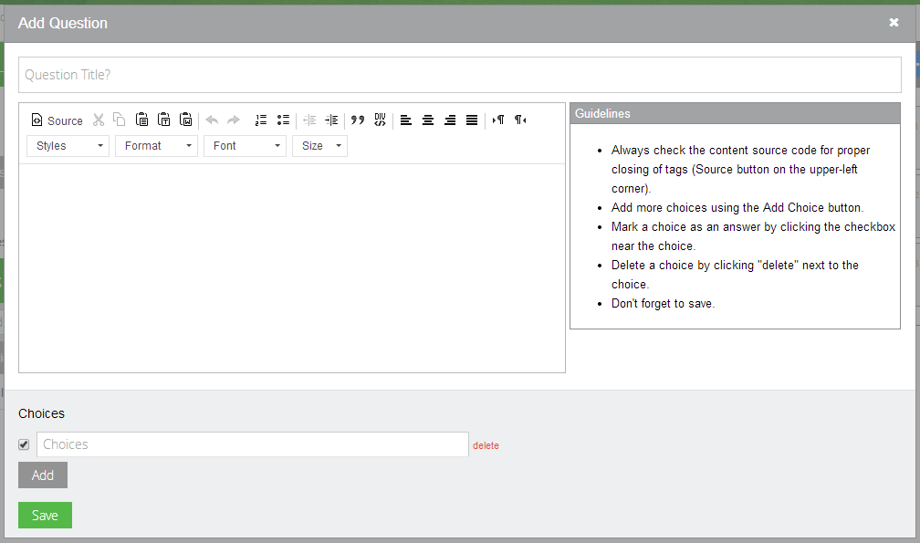

Title

Question Content

Choices and Answers

Check to mark as answer

Fill up the question title and content. You can use basic styling and formatting in the question content using the text editor. In the Choices area, you can add more choices using the Add button and delete choices by clicking the delete link beside each choice. Mark choices as answers by checking the checkbox before each choice. Click the Save button after you are done.

### Editing a Question

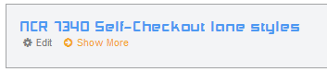

Click on the Edit link below the question title to edit a module question.

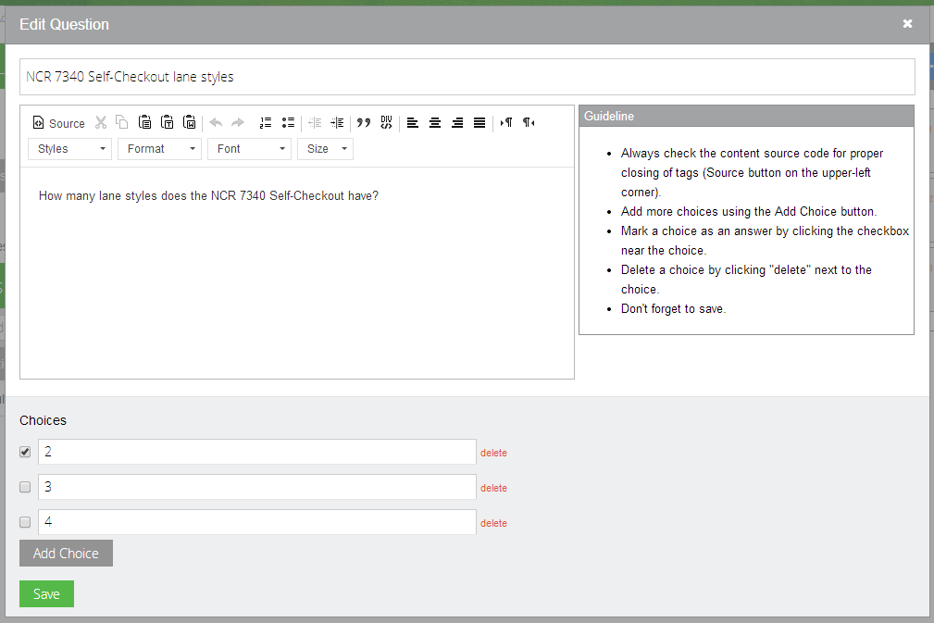

Title

Question Content

Choices and Answers

Check to mark as answer

The Edit Question form is the same as when you are Creating a Question. Refer to the section above.

### Viewing a Question



Click on the Show More link to view a question.

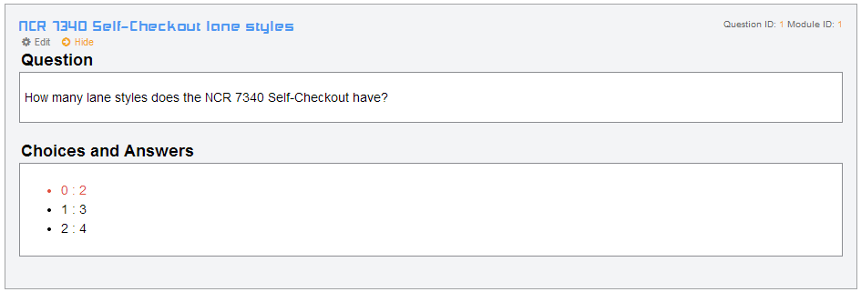

The highlighted red text indicates that that choice is the answer.

## Scheduled Tests

Scheduled tests are used to evaluate the trainees’ current knowledge regarding a module or topic. Scheduled tests are bound to a module. Trainees who have not enrolled in a module will not be able to take the scheduled tests for that module.

You can create a scheduled test by clicking on the link in the Actions pane when viewing Module Questions. You can also use the “Set up a Scheduled Test” link in the Test Results page.

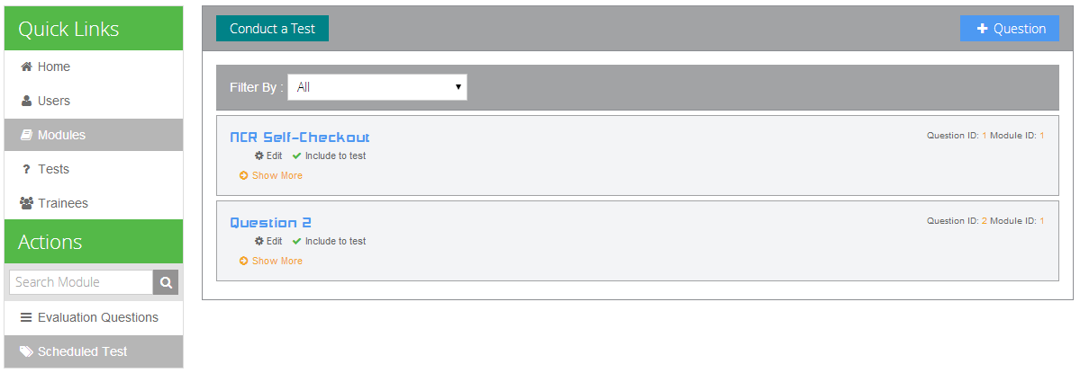

### Creating or Editing Scheduled Test Questions

Creating and editing scheduled test questions are similar to creating and editing questions for module tests. Please refer to those sections above.

### Including Questions to the Scheduled Test

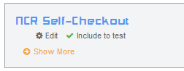

Click to include

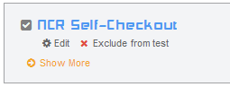

After you create a question, it is not automatically included to the scheduled test. You have to click “Include to test” link to add the question to the test. Clicking on “Exclude from test” will remove the question from the current test.

### Conducting the Scheduled Test

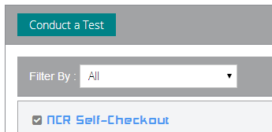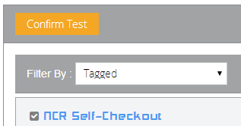

After adding the questions to the test, click on the “Conduct a Test” button and then “Confirm Test” to conduct the test and let the trainees answer it.

### Stopping the Scheduled Test

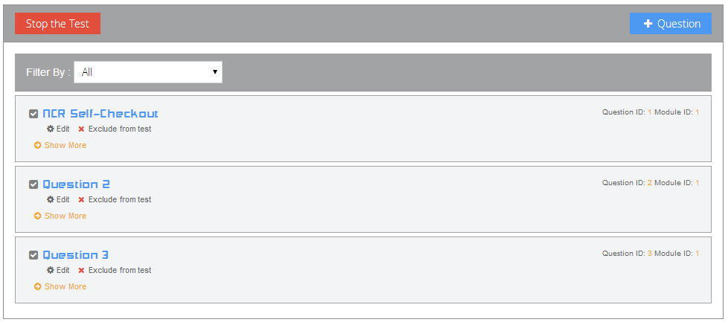

When all the trainees had answered the scheduled test, you stop the test by clicking on the button. After stopping the test, all the trainees will no longer have access to the test. You can then be able to view the test results.

## Test Results

The SSCO Module-Based Learning application records all the module and scheduled tests taken by the trainees. Click on the Tests link in the Quick Links pane to go to the Test Results page.

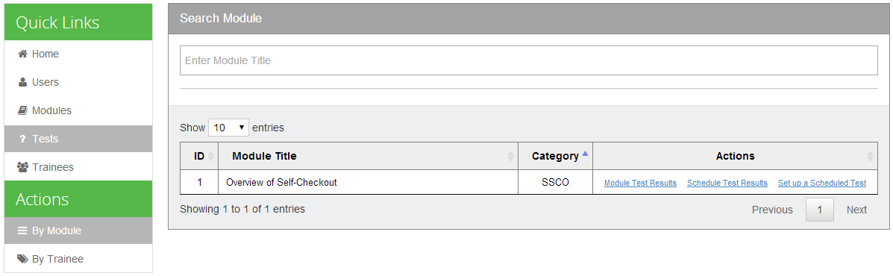

The test results by default are grouped according to modules. The table lists all the modules created and you will be able to view the test results per module by clicking on the links under the Actions column. You can view the module and scheduled test results as well as setup scheduled tests. You can also search for a module by using the search bar.

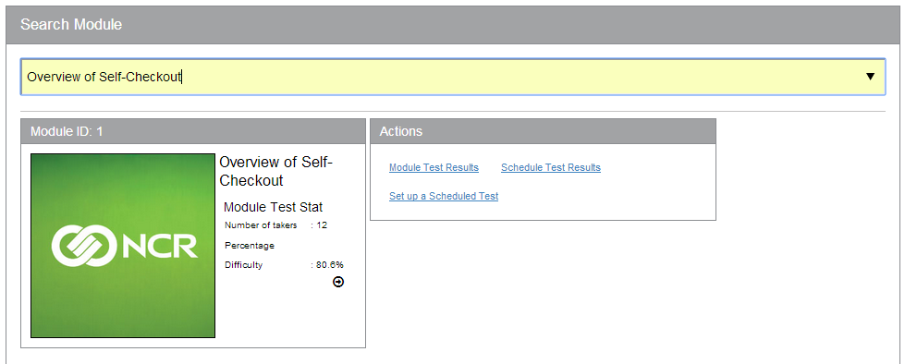

### Module Test Results

To view the information regarding a module’s test results, click on the module’s Module Test Results link from the Test Results page.

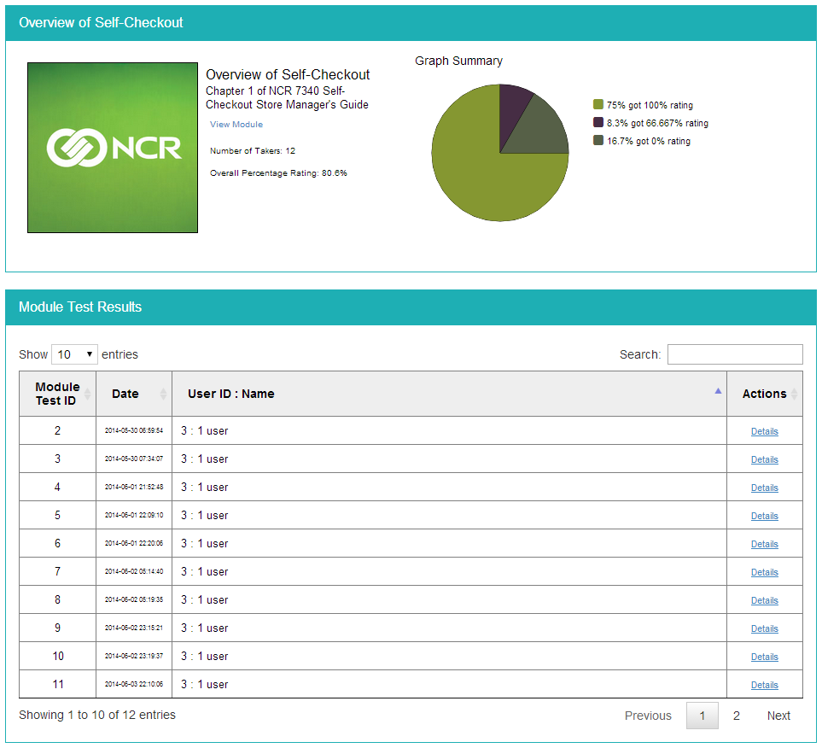

The Module Test Results page shows a summary about the module’s test takers and their scores. Then it lists all the tests taken by the trainees, where you can view a specific test result by clicking on the Details link under the Actions column.

### Scheduled Test Results

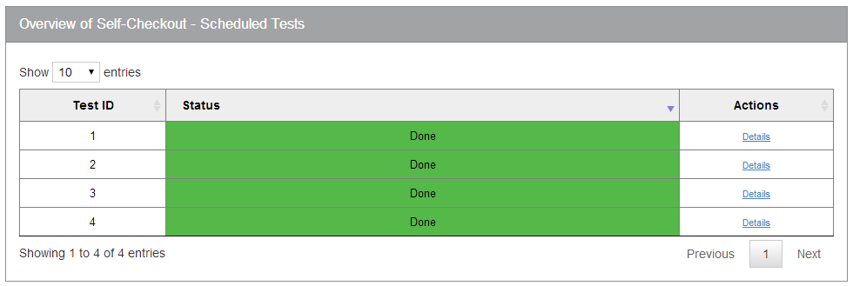

Clicking on the module’s Scheduled Test Results link from the Test Results page displays a list of all scheduled tests conducted for the module.

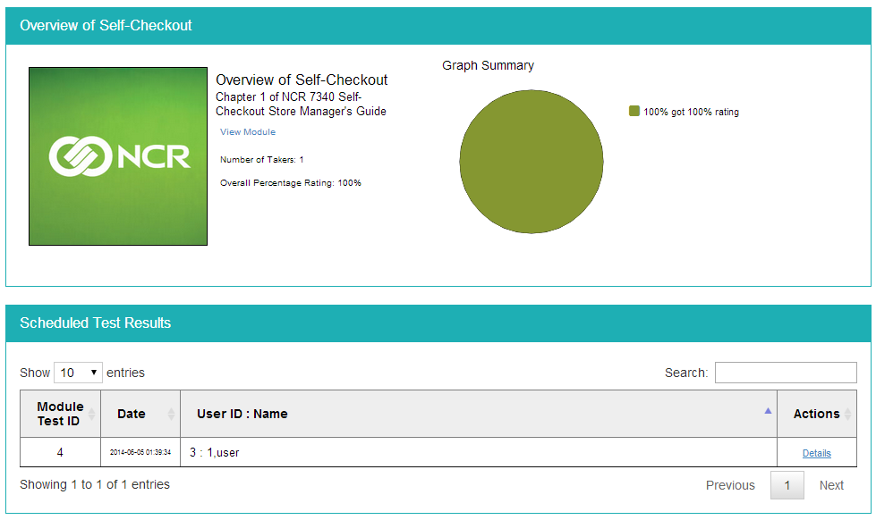

By clicking the Details link for a particular scheduled test, you can view the information about the scheduled test: some statistics as well as the list of test results. Click on the Details link to view a specific test result.

### Test Result Form

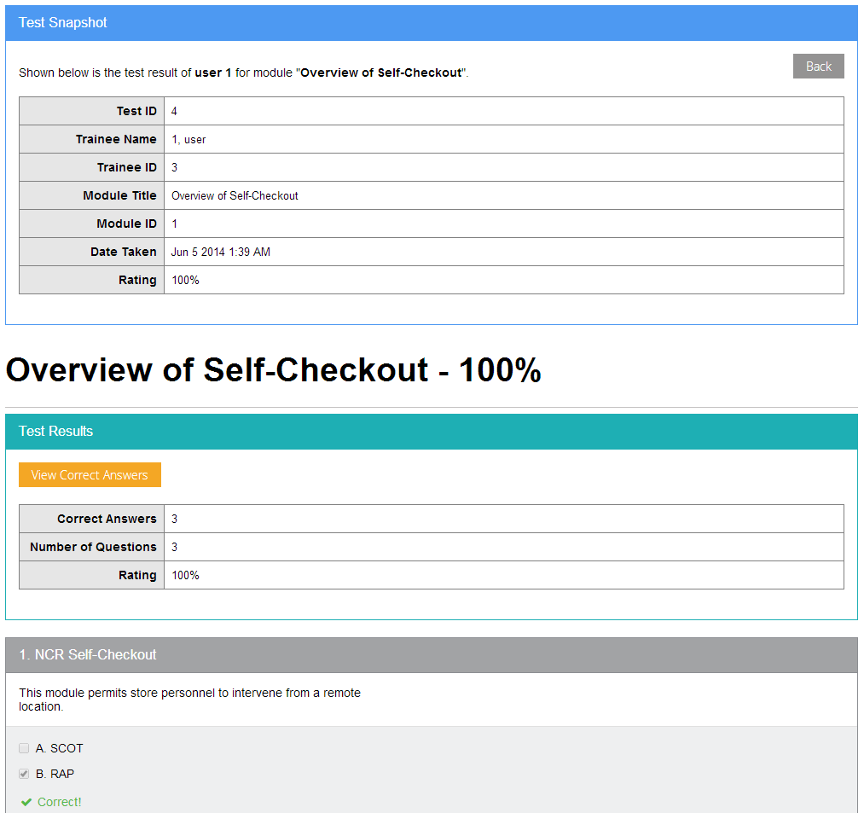

The Test Result Form shows information about the test result as well as the content of the test. You can view the correct answers for the test by clicking on the View Correct Answers button.

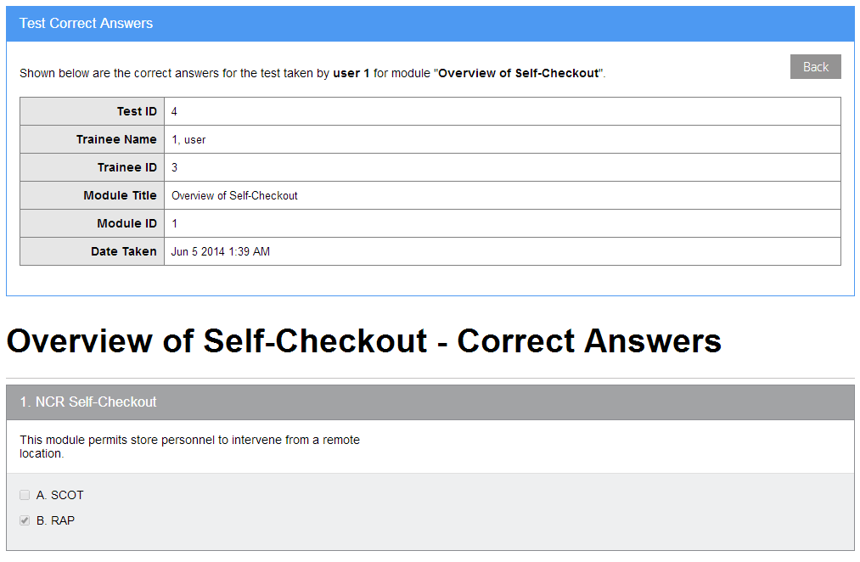

## Trainees

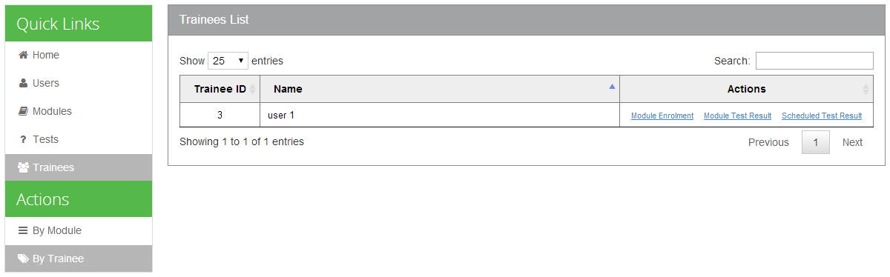

The Trainees page lists all of the trainees. Here, you can view a trainee’s module and scheduled test results. You can also perform module enrolment for the trainee.

### Module Test Results

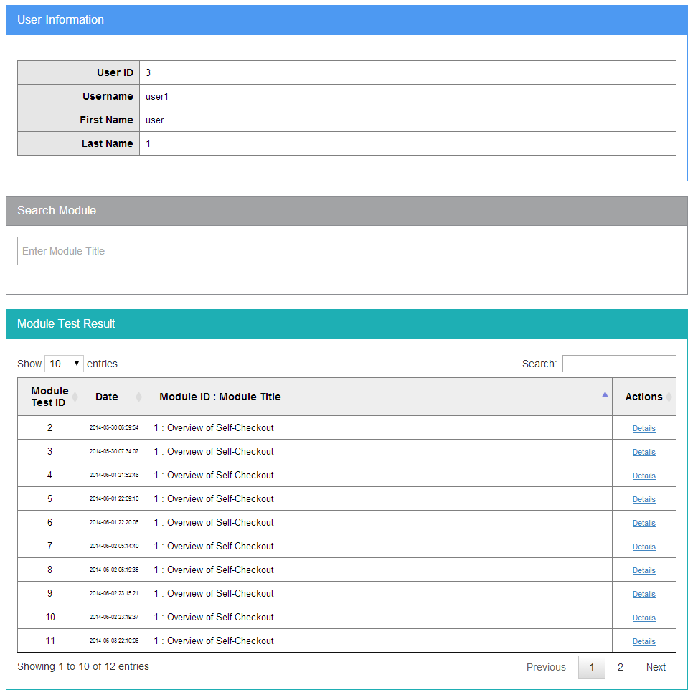

For filtering data

The Module Test Results page shows a list of all the module tests taken by the trainee. You can view a specific test result by clicking on the Details link under the Actions column. Using the search bar at the upper-right of the table, you can filter the data (by Date or by Module Title).

### Scheduled Test Results

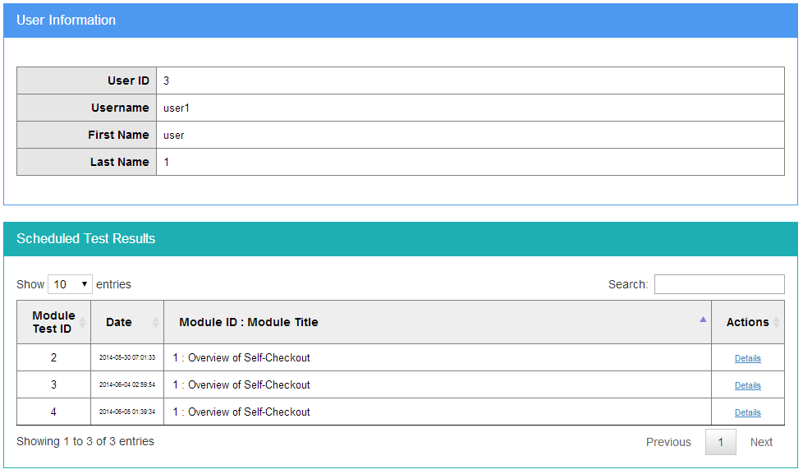

Clicking on the trainee’s Scheduled Test Results link from the Trainees page displays a list of all of the scheduled tests taken by the trainee. Click on the Details link for a particular scheduled test to view the test result.

### Module Enrolment

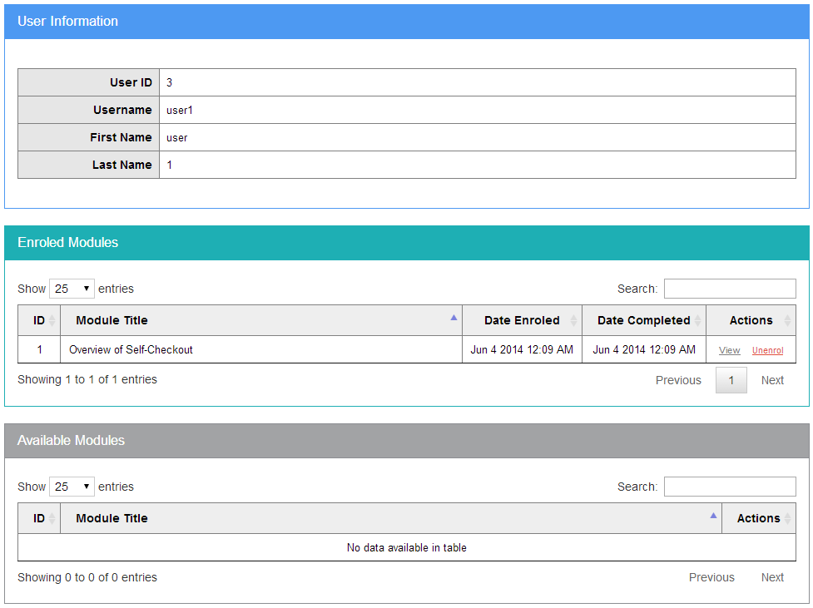

The Module Enrolment page lists all the modules that the trainee is enrolled in and allows you to enrol or unenrol a trainee from a module. Click on the Enrol/Unerol link to perform the action.

# Index

General Page Layout, 7

Main Content, 7

Sidebar, 8

Actions, 8

Quick Links, 8

Getting Started, 6

User Login, 6

Web Browser, 6

Home, 9

Module Questions, 24

Creating a Question, 25

Editing a Question, 26

Viewing a Question, 27

Modules, 14

Create Module, 16

Cover Picture, 17

Description, 17

Main Content, 19

Tags, 18

Title, 16

Deleting a Module, 22

Grid View, 15

List View, 14

Modify Module, 21

Search Module, 23

Viewing a Module, 22

Scheduled Tests, 28

Conducting the Scheduled Test, 29

Creating or Editing Scheduled Test Questions, 28

Excluding Questions from the Scheduled Test, 28

Including Questions to the Scheduled Test, 28

Stopping the Scheduled Test, 29

Test Results, 30

Correct Answers, 33

Module Test Results, 31

Scheduled Test Results, 32

Test Result Form, 33

Trainees, 35

Module Enrolment, 38

Module Test Results, 36

Scheduled Test Results, 37

Users, 10

Create User, 11

Delete User, 13

Edit User, 12

View User, 10

View Users, 10